**NLS_TERRITORY**

In Oracle, NLS_TERRITORY refers to the National Language Support (NLS) parameter that specifies the territory and conventions to use for various operations like date formatting, numeric formatting, and sorting. This parameter is part of the NLS settings, which allow customization of language-specific behavior in Oracle databases.

For example, the NLS_TERRITORY setting affects how dates are formatted, whether commas or periods are used as decimal separators, and the default currency symbol. It helps Oracle adapt to regional preferences and standards, ensuring that data is displayed and processed according to local conventions.

Setting NLS_TERRITORY correctly is important for applications that need to handle data from different regions or for multinational organizations where users in different countries may interact with the same database.

Setting it in the init.ora file ensures that it is applied every time the database instance is started. However, it can still be overridden at the session level by individual users if necessary.

Select Ename, Hiredate From Emp;

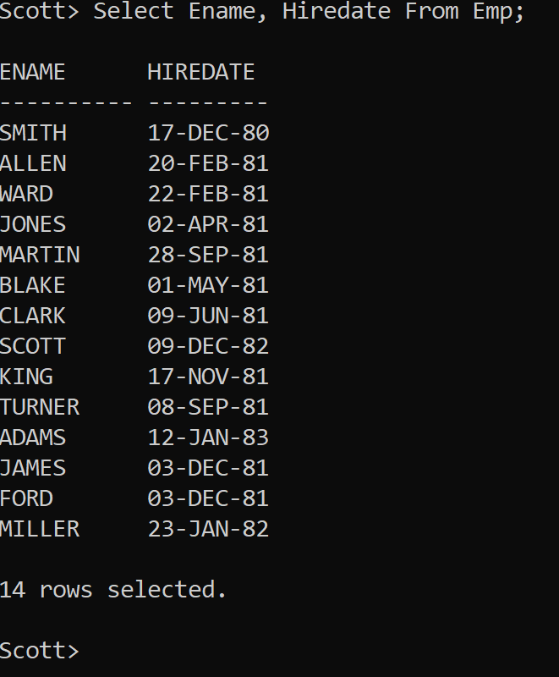

Now let’s change the NLS_Territory to Germany

ALTER SESSION SET NLS_TERRITORY = 'GERMANY';

Give the same SQL command again.

Select Ename, Hiredate From Emp;

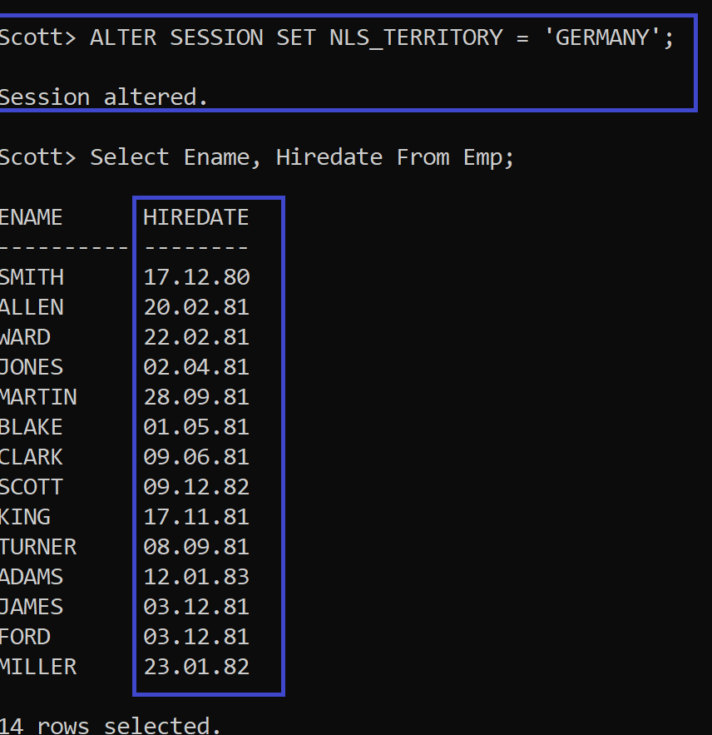

Now let’s change it to India

ALTER SESSION SET NLS_TERRITORY = 'INDIA';

Select Ename, Hiredate From Emp;

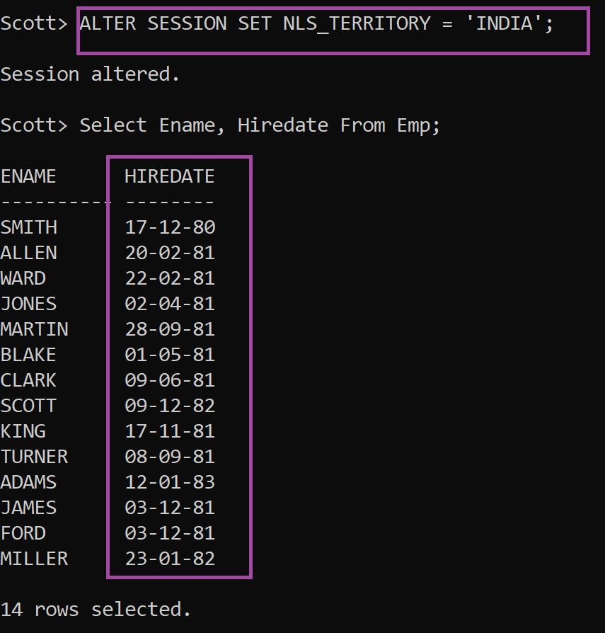

In Oracle, NLS_TERRITORY can be set to various values representing different territories or regions. Some of the common values include

1. **AMERICA**: This setting typically represents the United States and Canada.
2. **AUSTRALIA**: Represents Australia and New Zealand.
3. **CANADA**: Specifically for Canada.
4. **CHINA**: Represents China.
5. **FRANCE**: Represents France and French-speaking countries.
6. **GERMANY**: Represents Germany.
7. **JAPAN**: Represents Japan.
8. **KOREA**: Represents South Korea.
9. **UNITED KINGDOM**: Represents the United Kingdom.
10. **SWITZERLAND**: Represents Switzerland.
11. **BELGIUM**: Represents Belgium.
12. **ITALY**: Represents Italy.
13. **NETHERLANDS**: Represents the Netherlands.
14. **BRAZIL**: Represents Brazil.
15. **INDIA**: Represents India.
16. **SINGAPORE**: Represents Singapore.

These are just a few examples, and there may be additional territories or regions depending on the version of Oracle and its configuration. You can typically find the complete list of supported territories in the Oracle documentation specific to your Oracle Database version.